**DECENTRALISATION OF PATIENT INFORMATION**

**PROJECT REPORT**

***Submitted By***

Anjali Pandey

Roll No: 12620003022, Registration No: 201260100210062

Ishika Saha

Roll No: 12620002028, Registration No: 201260100210006

Md. Shafaullah

Roll No: 12620002031, Registration No: 201260100210052

***Under the Supervision of***

Prof. Satarupa Bagchi Biswas

Department of Information Technology

***In partial fulfilment for the award of the degree***

*Of*

**BACHELOR OF TECHNOLOGY**

In

**INFORMATION TECHNOLOGY**

**HERITAGE INSTITUTE OF TECHNOLOGY, KOLKATA**

**MAULANA ABUL KALAM AZAD UNIVERSITY OF**

**TECHNOLOGY, KOLKATA**

May 2024

**HERITAGE INSTITUTE OF TECHNOLOGY, KOLKATA**

***An Autonomous Institute under***

**MAULANA ABUL KALAM AZAD UNIVERSITY**

**OF TECHNOLOGY**

**BONAFIDE CERTIFICATE**

Certified that this project report on **“DECENTRALISATION OF PATIENT INFORMATION”** is the Bonafide work of **“ANJALI PANDEY, ISHIKA SAHA and Md. SHAFAULLAH”**, who carried out the project under my supervision.

**SIGNATURE**   **SIGNATURE**

Prof. (Dr.) Siuli Roy Prof. Satarupa Bagchi Biswas

**HEAD OF THE DEPARTMENT PROJECT MENTOR**

**Information Technology Information Technology**

**Heritage Institute of Technology Heritage Institute of Technology**

Kolkata 700107. Kolkata 700107.

**SIGNATURE**

**EXTERNAL EXAMINER**

**ACKNOWLEDGEMENT**

We would like to take this opportunity to thank **Prof. (Dr.)Siuli Roy**, Head of the Department of Information Technology for giving us the opportunity to work on this project.

We would also like to thank **Prof. Satarupa Bagchi Biswas**, our project mentor for constantly supporting us and guiding us throughout the project. Their guidance and words of encouragement motivated us to achieve our goal and impetus to excel. We also thank the technical staff of our department, **Mr. Shantanu Ghosh**, for providing us with all necessary facilities required for this project.

**Anjali Pandey**

**Ishika Saha**

**Md. Shafaullah**

**ABSTRACT**

In the current epoch of digital advancement, meticulous stewardship and safeguarding of patient information emerge as formidable challenges confronting healthcare systems on a global scale. While traditional centralized systems confer certain advantages, they inherently manifest limitations that impede the seamless exchange of data, compromise patient privacy, and adversely affect overarching healthcare outcomes.

Recognizing the imperativeness of devising alternative solutions to surmount these challenges, our research focuses deliberately on the nuanced exploration of the **"Decentralization of Patient Information."** This meticulously crafted study aspires to unravel the transformative potential latent within decentralized systems in the realm of healthcare. Our inquiry spans a comprehensive examination of their myriad benefits, the bedrock of their technological underpinnings, the intricate challenges entailed in their implementation, the labyrinthine landscape of regulatory considerations, and the discernment of prospects in this dynamic domain.

Conducting a thorough scrutiny encompassing realworld use cases, ethical considerations, and the conceivable impacts of decentralization, our intent is to furnish invaluable insights tailored for consumption by healthcare practitioners, policymakers, and technologists.

A discernible trend in recent years underscores an escalating interest in the decentralization of patient information, an inclination primarily propelled by the advent of blockchain technology. This innovative paradigm holds the potential to revolutionize the healthcare industry by furnishing solutions that are not only secure but also transparent and operationally efficient in the storage and dissemination of patient data.

**TABLE OF CONTENTS**

|  |  |  |
| --- | --- | --- |
| **CHAPTER NO.** | **TITLE** | **PAGE NO.** |
| **1** | **1. Introduction**  **1.1.** Background and Context  **1.2.** Significance and Objectives  **1.3.** Why Patient Information?  **1.4.** What is Decentralization?  **1.5.** Stakeholders  **1.6.** Why Decentralization? | 6 - 8 |
| **2** | **2. Literature Survey** | 9-18 |
| **3** | **3. Preliminary Ideas**  **3.1.** Blockchain  **3.2.** Hyperledger Fabric | 19-22 |
| **4** | **4. Our Work**  **4.1.** Flowchart of our entire process  **4.2.** Implementation of the project | 23-32 |
| **5** | **5. Dataset & Output**  **5.1.** Data Set  **5.2.** Output | 33-39 |
| **6** | **6. Conclusion and Future Work** | 40 |
| **7** | **7. References** | 41 |

1. **INTRODUCTION**

**1.1 Background and Context**

In the digital age, healthcare organizations face unprecedented challenges in effectively managing and securing patient information. Traditional centralized approaches to storing and exchanging patient data, although prevalent, come with inherent limitations that impede data interoperability, patient privacy, and overall healthcare outcomes. As researchers in the field of healthcare technology, we recognize the critical importance of exploring alternative solutions to overcome these challenges. Consequently, we have chosen to investigate the topic of "Decentralization of Patient Information" to shed light on the transformative potential of decentralized systems in healthcare.

**1.2 Significance and Objectives**

The significance of our chosen research topic lies in its potential to revolutionize the management and sharing of patient information in healthcare systems. By distributing patient data across multiple nodes or entities, decentralized systems offer enhanced data control, privacy preservation, and collaboration among stakeholders. Our research objectives include:

a. Understanding the limitations and challenges of traditional centralized systems in healthcare.

b. Examining the concept of decentralization, including its benefits and technological foundations.

c. Investigating real world use cases and implementations of decentralized patient information systems.

d. Analyzing regulatory considerations and legal frameworks relevant to decentralized healthcare.

e. Identifying the challenges and limitations of decentralization in healthcare.

**1.3 Why Patient Information?**

If a patient owns his/her medical information which is authorized by healthcare providers, then it would reduce the carriage of bulky report files to different hospitals. Also, it helps doctors and care givers to minutely assess and give the best of medical facilities to the patient. Ensuring privacy can promote more effective communication between physician and patient, which is essential for quality of care, enhanced autonomy, and preventing economic harm, embarrassment, and discrimination.

**1.4 What is Decentralization?**

During their lives, patients generate data that is stored in central databases because of various events at different facilities or via different software structures. The responsibility for the data usually lies with the respective operator of the database and not with the patient, which makes easy access to all data and control over the transfer and use of personal data almost impossible for them. So, with decentralization, a patient owns his/her information which is authorized and encrypted and can be used all over the globe for higher and broader medical assistance.

**1.5 Stakeholders**

**The Patient**

Decentralized clinical trials offer a vital solution to expand access for patients with limited opportunities in traditional settings. By embracing this approach, the life science industry takes a proactive step toward healthcare equality, fostering diversity in research participation. The use of digital tools not only enhances patient communication and participation but also contributes to improved recruitment rates and data accuracy, ensuring a more comprehensive and reliable representation in clinical trials.

**The Doctor**

Authorized medical reports save valuable time and resources during critical situations, eliminating the need for retests when admitted to different hospitals and thereby reducing unnecessary expenses. By ensuring that authorized reports reach doctors promptly, the decentralization of medical data facilitates more efficient patient care, enabling healthcare professionals to make well-informed decisions based on high-quality information. With patients in control of their medical data, experienced doctors can provide virtual consultations and treatments globally, empowering individuals to choose appropriate health services guided by the expertise of renowned medical professionals.

**1.6 Why Decentralization?**

There are several reasons why decentralization can be beneficial in healthcare:

**Increased efficiency:** Decentralization can reduce bureaucracy, allowing healthcare providers to respond more quickly and efficiently to patients' needs. This can result in faster diagnosis, treatment, and recovery times.

**Improved access:** By decentralizing healthcare, services can be brought closer to patients' homes, making it easier for them to access medical care. This can be especially important for patients who live in rural or remote areas, where healthcare facilities may be scarce.

**Better patient outcomes:** Decentralization can lead to more personalized care, as healthcare providers are better able to tailor treatments to the specific needs of individual patients. This can result in better health outcomes overall.

**Increased accountability:** Decentralization can encourage greater accountability among healthcare providers, as decision-making is distributed among multiple stakeholders. This can help to reduce the likelihood of errors and increase patient safety.

Overall, decentralization can lead to a more patient-centred healthcare system that is more efficient, effective, and responsive to patients' needs.

1. **LITERATURE SURVEY**
2. **Decentralized Patient-Centric E-Health Record Management System Using Blockchain and IPFS.**

Authors: Gaganjeet Singh Reen, Network Security & Cryptography Lab, IIIT Allahabad. Manasi Mohandas, Network Security & Cryptography Lab, IIIT Allahabad. S. Venkatesan, Network Security & Cryptography Lab, IIIT Allahabad

The research paper [1] introduces an innovative solution to the challenges in healthcare information management. Leveraging a permissioned Ethereum blockchain and cryptographic techniques, the system enables global connectivity for secure patient data exchange. The use of IPFS further enhances record storage with distributed and immutable characteristics. The strengths include transparent connectivity, tamper-resistant data exchange, secure storage, and decentralized, fault-tolerant record keeping. However, the paper acknowledges limitations. The reliance on online availability in the IPFS-based approach may hinder data access in scenarios with limited connectivity. Additionally, the absence of a mechanism to prevent unauthorized copying poses a risk to data confidentiality. The broader challenge of limited internet access for some individuals is also acknowledged. While the system shows promise, addressing these limitations through advanced technological solutions and collaborative efforts is essential for its effectiveness, security, and inclusivity in diverse healthcare scenarios. The paper lays a foundation for future exploration and refinement in decentralized patient-centric e-health record management systems.

**Drawbacks:**

**i. Online Dependency:** The system relies on online availability for data sharing through IPFS, potentially causing challenges in scenarios with limited or intermittent network connectivity.

**ii. Unauthorized Copying:** The absence of mechanisms to prevent unauthorized copying poses a risk to patient data confidentiality, emphasizing the need for additional security measures like digital rights management or watermarking.

**iii. Internet Accessibility Challenges:** A broader challenge highlighted is the uneven distribution of internet access globally, especially in underserved regions.

1. **A Survey: Blockchain-based Electronic Health Record System**

Authors: Gaurang Awatade1, Gaurav Kasure2, Suyog Padole3, Yash Choudhary4, Shital Sungare5, Anil Kumar Gupta6,1,2,3,4Student, Department of Computer Engineering, Dr. D. Y. Patil Institute of Technology, Pune, India. 5Professor, Department of Computer Engineering, Dr. D. Y. Patil Institute of Technology, Pune, India 6Senior IEEE Member

The research paper titled [2] introduces an innovative approach to tackle the challenges of secure record distribution and access control in healthcare. Leveraging the Ethereum blockchain, the system empowers patients by granting them control over the distribution of their health records and implements role-based access control for added security. The patient-centric model enhances privacy and autonomy, allowing individuals to decide who can access their sensitive medical information. The use of role-based access control ensures that only authorized individuals can access specific patient records, reducing the risk of unauthorized access. The hybrid data storage approach, with hash values on the blockchain and actual data in the Electronic Health Record (EHR) system, ensures data integrity, immutability, and efficient retrieval. However, the paper identifies potential drawbacks, including cost considerations for frequent transactions on the Ethereum blockchain and vulnerabilities associated with smart contracts. These limitations necessitate further research and technological advancements to ensure the scalability, affordability, and robustness of the proposed system in healthcare settings. Despite these challenges, the paper provides valuable insights, setting the stage for future exploration and refinement of patient-controlled record distribution systems utilizing the Ethereum blockchain.

**Drawbacks:**

**i. Cost Challenges:** Frequent transactions on the Ethereum blockchain may incur significant transaction fees and gas costs, presenting a potential financial barrier for healthcare organizations, especially those with limited resources.

**ii. Smart Contract Vulnerabilities:** The reliance on smart contracts introduces a vulnerability to coding errors or bugs, posing a risk to the security and integrity of patient records. Rigorous testing and best coding practices are emphasized, but ongoing attention is required to mitigate these potential weaknesses. Addressing these drawbacks is essential for ensuring the scalability, affordability, and robustness of the proposed electronic health record system.

1. **Centralized versus Decentralized Management of Parents’ Medical Records**

Authors: Catherine Quantin, Centre Hospitalier Universitaire de Dijon. Gouenou Coatrieux, IMT Atlantique, France, Brest. Vincent Breton, Institut National de Physique Nucléaire et de Physique des Particules. David-Olivier Jaquet-Chiffelle, University of Lausanne

The research paper titled [3] introduces an innovative solution to the challenges inherent in centralized storage systems within the healthcare domain. By advocating the use of grid technology for distributed medical data management, the paper aims to surmount the limitations associated with centralized storage, emphasizing enhanced accessibility, availability, and scalability. The critical evaluation of the proposed system delves into its strengths and limitations, focusing on the advantages of grid technology, the intricacies of implementation, potential inconsistencies in medical records, and security risks inherent in grid technology. Grid technology is lauded for overcoming centralized storage limitations, offering improved accessibility and scalability. However, the paper underscores the complexity of implementing and managing grid-based Electronic Health Record (EHR) systems, necessitating specialized expertise and dedicated resources. The distributed nature of grid technology raises concerns about potential inconsistencies in medical records, highlighting the importance of standardized protocols for data integrity. Furthermore, the research paper acknowledges security risks associated with grid technology, emphasizing the need for robust security measures and access controls to ensure the confidentiality, integrity, and availability of sensitive medical data. The proposed "Google-like" access grid technology prompts considerations for access management, stressing the significance of well-defined access control frameworks and user authentication mechanisms. In conclusion, while the paper contributes valuable insights by leveraging grid technology to address centralized storage limitations, the identified challenges necessitate careful consideration and further exploration to ensure the successful implementation and adoption of grid-based solutions for secure and distributed medical data management in healthcare settings.

**Drawbacks:**

**i. Complex Implementation:** Implementing grid technology for Electronic Health Records (EHR) is complex, demanding specialized expertise and dedicated resources, potentially posing challenges for adoption.

**ii. Inconsistencies in Records:** The distributed nature of grid technology may lead to inconsistencies in medical records across nodes, necessitating standardized protocols for data consistency.

**iii. Security Risks:** Grid technology introduces security risks if not properly configured, emphasizing the need for robust measures like access control, encryption, and continuous monitoring to thwart potential exploits.

1. **Decentralized Patient-Centric Report and Medical Image Management System Based on Blockchain Technology and the Inter-Planetary File System.**

Authors: Syed Agha Hassnain Mohsan Ocean College, Zhejiang University, Zheda Road 1, Zhoushan 316021, China, Abdul Razzaq Department of Computer Science and Software Engineering, International Islamic University, Islamabad 44000, Pakistan. Shahbaz Ahmed Khan Ghayyur Department of Information Systems, College of Computer and Information Sciences, Princess Nourah bint Abdulrahman University, Riyadh 11671, Saudi Arabia. Hend Khalid Alkahtani Department of Health Information Management and Technology, College of Public Health, Imam Abdulrahman Bin Faisal University, Dammam 31441, Saudi Arabia, Nouf Al-Kahtani and Samih M. Mostafa Department of Computer Science, Faculty of Computers and Information, South Valley University, Qena 83523, Egypt

The research paper [4] introduces an innovative solution to enhance patient privacy and control in healthcare. The system utilizes an Ethereum blockchain, Metamusk, and the Interplanetary File System (IPFS) to establish a decentralized and secure Patient-Controlled Records and Identity Management (PCRIM) framework. The patient-centric approach empowers individuals, ensuring data privacy and control over medical images and reports. The integration of IPFS enables efficient distributed data access, enhancing healthcare service delivery. However, the paper highlights considerations, such as Ethereum platform costs for transactions and performance delays in Metamusk's smart contract execution cell. Additionally, potential threats to internal validity are acknowledged, necessitating rigorous testing and monitoring for consistent real-world performance. Despite these limitations, the proposed system presents valuable insights for decentralized healthcare, serving as a foundation for future advancements.

**Drawback:**

**i. Ethereum Platform Costs:** Transaction costs on the Ethereum platform pose financial challenges for healthcare organizations, potentially impacting the system's cost-effectiveness.

**ii. Metamusk Performance Limitations:** Delays in fetching larger files due to Metamusk's smart contract execution cell may hinder timely access to medical records, particularly affecting healthcare decision-making.

1. **pubHeal – A Decentralized Platform on Health Surveillance of People**

Authors: Sonam Sharma, Research & Innovation A&I, Tata Consultancy Services, New Delhi

The research paper [5] introduces a permissioned decentralized approach for the distribution and storage of patient and healthcare-related data using the Hyperledger Fabric framework. Leveraging the features of Hyperledger Fabric, the system ensures secure data access and storage, particularly crucial during disaster events when comprehensive medical information is vital for effective care. The report explores the benefits of Hyperledger Fabric, such as eliminating cryptocurrency prerequisites and facilitating confidential transactions. However, a limitation is identified as the current focus on storing only textual data, prompting the proposed integration of the InterPlanetary File System (IPFS) for handling unstructured reports and images. The report discusses Hyperledger Fabric's benefits, its permissioned nature, and the future integration of IPFS. Security and privacy considerations are emphasized, underscoring the need for robust protocols and regulatory compliance. The conclusion suggests that the combination of Hyperledger Fabric and IPFS holds promise for enhancing medical data management during disasters, calling for further research to address security, privacy, and scalability challenges in real-world scenarios.

**Drawbacks:**

**i. Textual Data Focus:** The system's current limitation lies in storing only textual data, lacking provision for unstructured reports or images.

**ii. IPFS Integration Needed:** To address the limitation, the report proposes the integration of the InterPlanetary File System (IPFS) for comprehensive handling of unstructured data.

**iii. Cost Considerations:** The report acknowledges the costs associated with each transaction on the Ethereum platform, emphasizing the need for careful cost management, especially for healthcare organizations with limited resources.

1. **An intelligent blockchain strategy for decentralized healthcare framework.**

Authors: Akanksha Goel, School of Computing, Bharath Institute of Higher Education and Research, Chennai, Tamil Nadu 600073, India. S. Neduncheliyan, Dr. D.Y. Patil Biotechnology and Bioinformatics Institute, Pune 411033, India

The paper [6] presents a novel hybrid Deep Belief-based Diffie Hellman (DBDH) security framework designed to protect medical data from malicious events. Combining deep learning algorithms and cryptographic techniques, the framework ensures patient privacy and healthcare system integrity. It leverages the Internet of Things (IoT) and the Internet of Medical Things (IoMT) during the COVID-19 pandemic for remote patient monitoring and device integration. Findings indicate improved security with reduced encryption and decryption time, enhanced confidentiality, minimized execution time, and reduced error scores. The discussion explores implications for healthcare systems and patient privacy, while recognizing areas for further research. The hybrid DBDH framework, along with IoT and IoMT integration, demonstrates potential to advance medical data security practices.

**Drawbacks:**

**i. Limited Consideration for Unstructured Data:** The framework primarily focuses on textual data, lacking provisions for handling unstructured data types like images.

**ii. Potential Scalability Challenges:** There's a need for further research to address scalability challenges associated with the framework's implementation, ensuring effective performance as the system scales.

**iii. Vulnerability Concerns:** While reducing encryption and decryption time is beneficial, potential vulnerabilities should be carefully considered, emphasizing the importance of robust security measures.

1. **A Blockchain-Based Secure Storage Scheme for Medical Information.**

Authors: [Zhijie Sun](https://jwcn-eurasipjournals.springeropen.com/articles/10.1186/s13638-022-02122-6#auth-Zhijie-Sun-Aff1), [Dezhi Han](https://jwcn-eurasipjournals.springeropen.com/articles/10.1186/s13638-022-02122-6#auth-Dezhi-Han-Aff1), [Dun Li](https://jwcn-eurasipjournals.springeropen.com/articles/10.1186/s13638-022-02122-6#auth-Dun-Li-Aff1-Aff2), [Xiangsheng Wang](https://jwcn-eurasipjournals.springeropen.com/articles/10.1186/s13638-022-02122-6#auth-Xiangsheng-Wang-Aff1), [Chin-Chen Chang](https://jwcn-eurasipjournals.springeropen.com/articles/10.1186/s13638-022-02122-6#auth-Chin_Chen-Chang-Aff3) & [Zhongdai Wu](https://jwcn-eurasipjournals.springeropen.com/articles/10.1186/s13638-022-02122-6#auth-Zhongdai-Wu-Aff4)

This review paper critically evaluates a research paper [7]. The research paper introduces a novel approach that utilizes Hyperledger Fabric, an enterprise permissioned blockchain fabric, and IPFS (InterPlanetary File System) for secure storage of medical information. The paper explores the integration of Merkle DAG (Directed Acyclic Graph) and attribute-based access control framework to enhance security and privacy. The review critically assesses a research paper introducing a blockchain-based secure storage scheme for medical information, leveraging Hyperledger Fabric, IPFS, Merkle DAG, and attribute-based access control. It discusses the integration of Hyperledger Fabric and IPFS, emphasizing security and access control enhancements. The paper explores future directions, including user-friendly interfaces, cross-platform compatibility, and optimization. While acknowledging the innovative aspects, the review underscores the need for further research and development to address limitations and enhance the overall efficiency and usability of the proposed secure storage scheme in healthcare.

**Drawbacks:**

**i. CLI Usability:** The reliance on Command Line Interface (CLI) may hinder user-friendliness, potentially impacting the ease of use for non-technical users.

**ii. Operating System Compatibility:** The system's compatibility limited to Ubuntu Linux OS may restrict broader adoption across various operating systems, posing a potential barrier.

**iii. Access Time:** Concerns about the potential impact on access time for retrieving medical records suggest the need for optimizations to ensure efficient and timely access to critical information.

**iv. Efficiency of Operations:** The efficiency of add and update operations, highlighted as a potential challenge, may require improvements to streamline processes and minimize time-consuming tasks.

1. **Blockchain in Healthcare: A New Technology Benefit for Both Patients and Doctors**

Authors: [Tran Le Nguyen](https://ieeexplore.ieee.org/author/37086482680) Department of Economics, Ho Chi Minh City University of Economics and Finance (UEF), Ho Chi Minh City, Vietnam

The research paper [8] explores the transformative potential of blockchain in the healthcare industry, emphasizing benefits for patient outcomes and doctor-patient interactions through a smartphone application. The review paper assesses strengths such as increased accessibility and integrated payment but notes limitations, including the model's focus on the United States and typical surgery procedures, the exclusive use of Bitcoin, reliance on two blockchains potentially increasing overhead, and the requirement for patient document scanning. While acknowledging the positive impacts, careful consideration of these limitations is crucial for optimizing the applicability of blockchain in diverse healthcare environments, necessitating further research and customization efforts.

**Drawbacks:**

**i. Regional Limitation:** The model is tailored specifically for the United States, potentially limiting its applicability in healthcare systems with different structures or payment methods in other countries.

**ii. Procedure Focus:** The emphasis on typical surgery procedures may restrict the model's effectiveness in addressing broader healthcare procedures, potentially limiting its scope and relevance.

**iii. Bitcoin Exclusivity:** Relying exclusively on Bitcoin for payments may pose challenges, as it limits flexibility and may not align with broader financial ecosystems or regulatory considerations.

**iv. Dual Blockchain Usage:** The utilization of two blockchains introduces potential drawbacks, including increased overhead, scalability challenges, higher computational requirements, and potential interoperability issues.

1. **SEMRAchain: A Secure Electronic Medical Record Based on Blockchain Technology**

Authors: Halima Mahmdi, [Manel Ayadi,](https://sciprofiles.com/profile/2410793?utm_source=mdpi.com&utm_medium=website&utm_campaign=avatar_name) [Amel Ksibi,](https://sciprofiles.com/profile/2031610?utm_source=mdpi.com&utm_medium=website&utm_campaign=avatar_name) [Amal Al-Rasheed,](https://sciprofiles.com/profile/1168917?utm_source=mdpi.com&utm_medium=website&utm_campaign=avatar_name) [Ben Othman Soufiene](https://sciprofiles.com/profile/40137?utm_source=mdpi.com&utm_medium=website&utm_campaign=avatar_name)

The research paper [9] produces a pioneering system for electronic medical record management leveraging blockchain. This review critically assesses [9] highlighting its strengths and limitations. The incorporation of role-based access control (RBAC) and attribute-based access control (ABAC), consideration of multiple agents, and authentication using smart contracts underscore its robust security framework. However, challenges such as Ethereum's cost and throughput implications, compatibility issues with Windows 10 OS, the need for user-friendly smart contract deployment, and administrative responsibilities in user addition present notable considerations. While [9] shows promise, addressing these limitations through further research and development is essential to optimize its effectiveness and usability in secure electronic medical record management.

**Drawbacks:**

**i. Cost and Throughput Implications:** The use of Ethereum for smart contract deployment in SEMRAchain may incur costs in terms of Ether, potentially affecting the system's overall throughput and efficiency.

**ii. Compatibility Limitation:** SEMRAchain's compatibility with Windows 10 OS may limit its adoption and usability, posing challenges in cross-platform compatibility and interoperability.

**iii. User-Friendly Smart Contract Deployment:** The user-friendliness of smart contract deployment within SEMRAchain needs improvement to enhance usability and accessibility, crucial for efficient adoption.

**iv. Administrative Responsibilities:** The administrative role in adding users, particularly patients, introduces governance, user management, and security considerations, requiring careful handling to mitigate potential challenges and risks.

1. **PRELIMINARY IDEAS**

**3.1 BLOCKCHAIN**

Blockchain technology is a revolutionary and decentralized approach to recording and verifying transactions across a network of computers. Originally conceptualized as the underlying technology for cryptocurrencies like Bitcoin, its applications have expanded far beyond digital currencies. At its core, a blockchain is a distributed ledger that maintains an immutable record of transactions through a chain of interconnected blocks.

One of the key features of blockchain is decentralization. Traditional databases are often centralized, meaning they are controlled by a single entity. In contrast, blockchain operates on a peer-to-peer network, where each participant (node) has a copy of the entire ledger. This decentralization brings transparency and eliminates the need for central authority, fostering trust among participants.

The structure of a blockchain consists of blocks, each containing a list of transactions. Once a block is filled with transactions, it is cryptographically linked to the previous block, forming a chain. This chaining mechanism ensures that altering a single block would require changing all subsequent blocks, making the blockchain resistant to tampering.

Consensus mechanisms play a vital role in maintaining the integrity of the blockchain. They are protocols that enable nodes to agree on the state of the ledger. Proof-of-Work (PoW) and Proof-of-Stake (PoS) are common consensus mechanisms. PoW involves solving complex mathematical puzzles to validate transactions and create new blocks, while PoS selects validators based on the amount of cryptocurrency they hold.

Smart contracts are self-executing contracts with the terms of the agreement directly written into code. They operate on the blockchain, automatically enforcing and executing the terms when predefined conditions are met. This eliminates the need for intermediaries, streamlining processes and reducing the risk of fraud.

Blockchain's applications extend to various industries beyond finance. In healthcare, it ensures the secure and transparent sharing of patient data. Supply chain management benefits from blockchain's ability to trace the origin and journey of products. Governments explore blockchain for transparent voting systems, reducing electoral fraud.

Despite its transformative potential, challenges remain. Scalability, energy consumption (in PoW-based blockchains), and regulatory uncertainties are among the issues that developers and stakeholders continue to address. As technology evolves, blockchain stands as a foundational element shaping the future of secure, transparent, and decentralized digital interactions.

**3.2 HYPERLEDGER FABRIC**

Hyperledger Fabric is a robust, permissioned blockchain platform that plays a pivotal role in advancing decentralized solutions for various industries. Developed by the Linux Foundation, it stands out as a prominent project within the Hyperledger umbrella, offering a modular and flexible framework for creating enterprise-grade blockchain applications.

At its core, Hyperledger Fabric is designed to address key challenges associated with decentralization, particularly in the context of business networks. It employs a permissioned model, allowing only authorized participants to join the network, which is essential for industries where data confidentiality and regulatory compliance are paramount. This feature distinguishes it from public blockchains like Bitcoin and Ethereum, making it well-suited for enterprise applications.

The significance of Hyperledger Fabric in achieving decentralization lies in its ability to establish trust and transparency among participants without compromising on privacy. Smart contracts, known as "chaincode" in Hyperledger Fabric, facilitate the execution of predefined rules and agreements. The modular architecture allows for the use of different consensus algorithms, providing flexibility to meet diverse business requirements.

One of the key benefits of Hyperledger Fabric is its focus on scalability and performance. Through its innovative consensus mechanisms and efficient endorsement policies, it can handle many transactions per second. This is crucial for enterprise scenarios where high throughput is essential for maintaining business operations.

Another advantage is its support for permissioned channels, enabling the creation of private sub-networks within the larger blockchain network. This allows for confidential transactions to occur only among selected participants, a feature particularly appealing to industries like finance and healthcare.

Hyperledger Fabric also provides a robust identity management system, ensuring that participants are authenticated and authorized appropriately. This enhances security and ensures that only trusted entities engage in the network, contributing to the overall reliability of the blockchain.

**Smart Contract**

A smart contract is a self-executing contract with the terms of the agreement directly written into code. Operating on blockchain platforms like Ethereum, these automated contracts enable trustless and decentralized execution of predefined actions when specific conditions are met. By eliminating intermediaries, smart contracts enhance transparency, security, and efficiency in various domains, from finance to supply chain. Users can rely on the tamper-resistant nature of blockchain technology to ensure the integrity of these contracts, streamlining processes and fostering a new era of decentralized applications and automated agreements.

**Ledger**

In Hyperledger Fabric, a ledger is a core component responsible for recording, storing, and maintaining the sequence of transactions. Unlike traditional ledgers, Hyperledger Fabric utilizes a permissioned blockchain framework, allowing only authorized participants to access and validate transactions. The ledger is maintained collectively by network participants, ensuring a distributed and tamper-resistant record of all interactions. Hyperledger Fabric employs two types of ledgers: the World State, which represents the current state of assets, and the Transaction Log, capturing the history of transactions. This dual-ledger approach enhances efficiency, scalability, and privacy in enterprise blockchain applications, making Hyperledger Fabric a robust solution for business networks.

In conclusion, Hyperledger Fabric stands as a cornerstone in the journey towards decentralization in enterprise blockchain applications. Its focus on permissioned access, scalability, privacy, and security makes it an ideal choice for businesses seeking to harness the benefits of blockchain technology while adhering to regulatory requirements and maintaining data confidentiality.

**4. OUR WORK**

**4.1 Flowchart of our entire project**

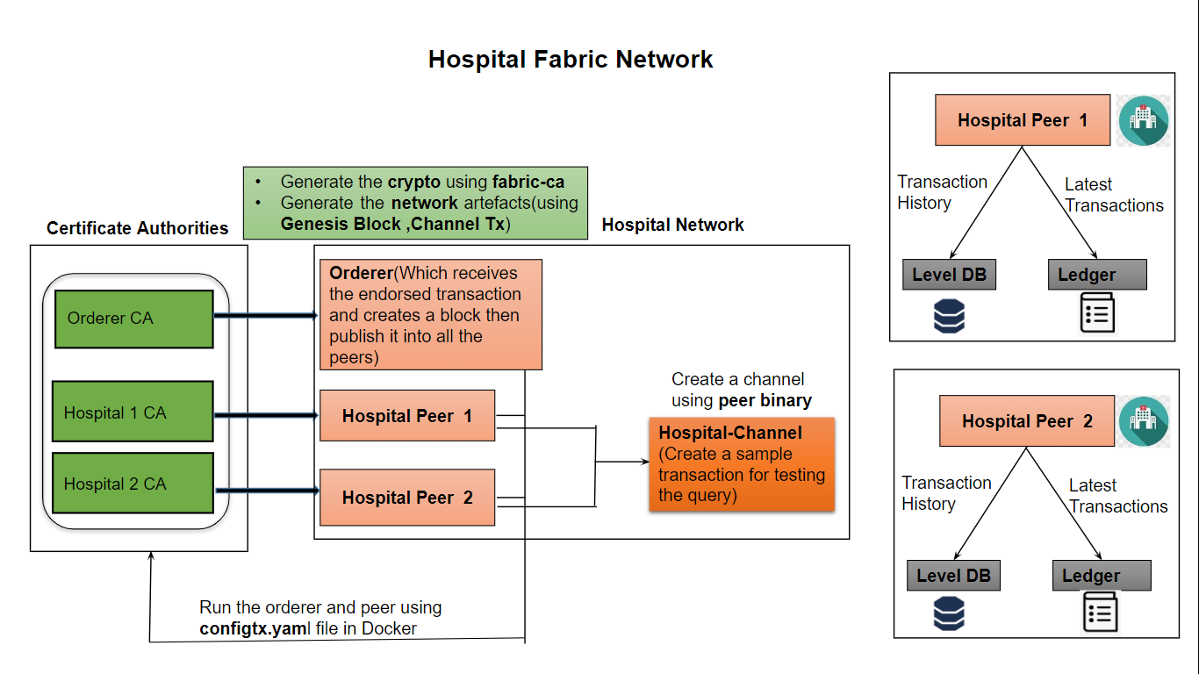

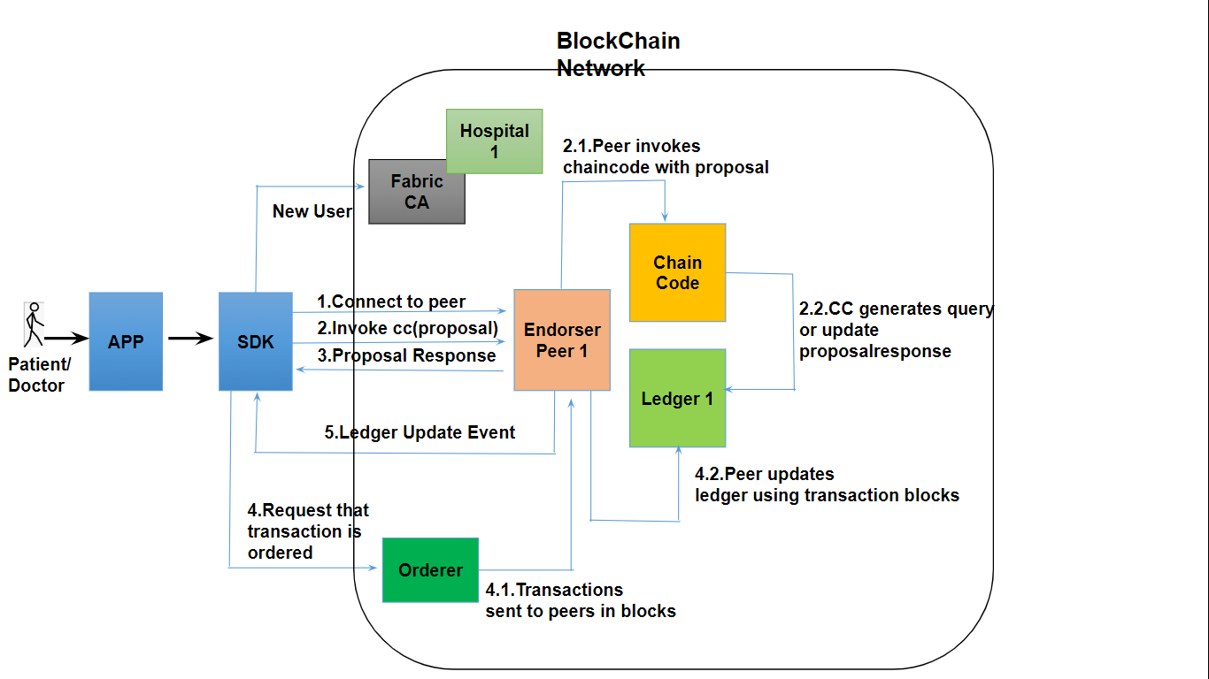

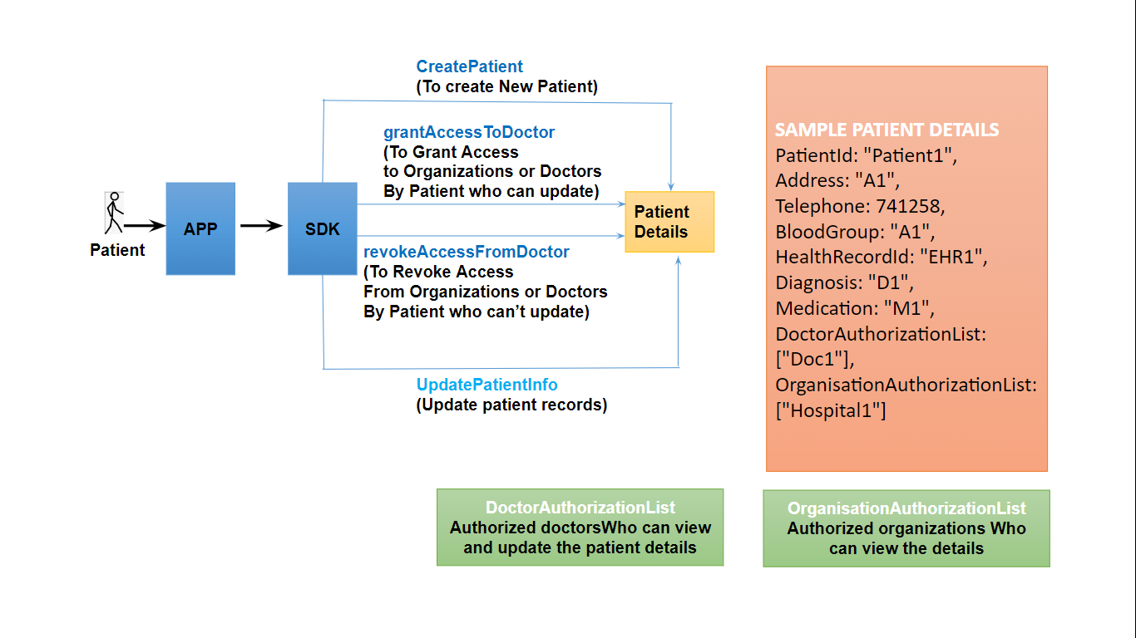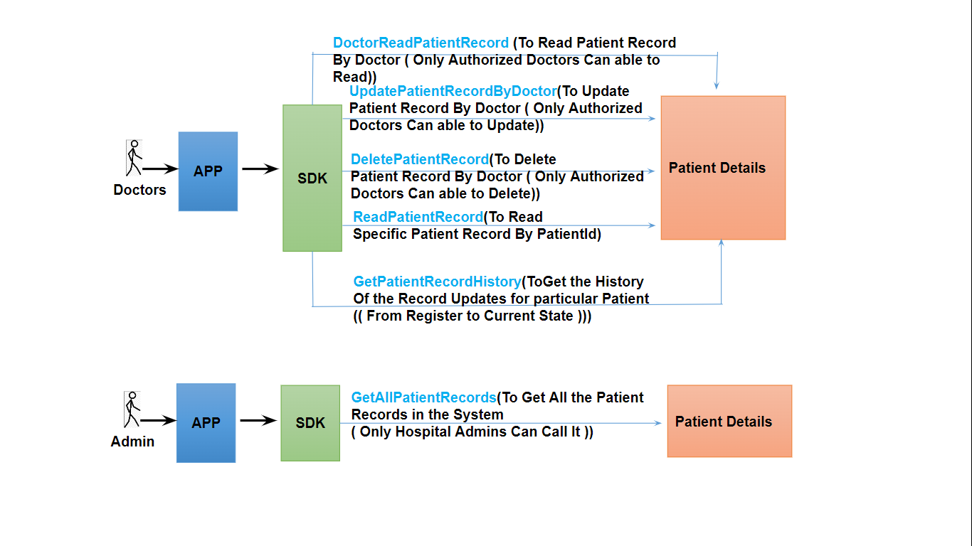

**4.2 Implementation of the project**

Patient data management solution built on Hyperledger Fabric provides a highly secure and scalable platform for sharing patient data across healthcare providers.

With advanced features such as smart contracts, access control, and consent management, we ensure that patient data is accessed only by authorized parties and in a transparent manner.

With a focus on patient privacy and security, our solution empowers healthcare providers to make informed decisions and deliver the best possible care to their patients' satisfaction.

**A. Blockchain Infrastructure and User Interfaces for Healthcare Data Management**

**1.Admin, Patient and Doctor Contract:**

In a smart contract system, contracts serve as self-executing agreements where the terms are directly encoded into the system's code. Within this framework, there exist two distinct types of contracts: the admin contract and the patient contract.

1. The admin contract is tasked with overseeing functions associated with enrollment, encompassing activities such as adding new users, verifying identities, and managing permissions within the healthcare network.
2. The patient contract is tailored to manage operations specific to patient-related activities. This can range from storing patient data to updating records and facilitating queries related to patients.
3. This description prompts the creation of a doctor contract, specifically designed to interact with the system's updatepatientdetails routes. This contract would empower authorized doctors to efficiently update patient details within the blockchain-based healthcare system, enhancing the overall functionality of the decentralized data management solution.

**2. Hospital Network Initialization:**

When the hospital network is initiated, it implies the setup and activation of the entire blockchain network specific to the hospital. This involves configuring nodes, establishing communication channels, and initializing the necessary components.

**3. Chaincode Installation:**

Once the hospital network is up and running, the chaincode is installed. Chaincode, in the context of Hyperledger Fabric, represents the smart contract logic. It defines the rules and processes that govern transactions on the blockchain.

**4. Server:**

The admin server is a component of the system that handles administrative tasks. It's mentioned that this server starts automatically without the need for the command *'npm run enroll*.' This suggests that the enrollment process, likely involving user registration or identity verification, is seamlessly integrated into the server startup routine.

**5. Wallet Creation:**

Upon the startup of the admin server, a wallet is created. A wallet in the context of blockchain typically refers to a secure place to store cryptographic keys and credentials. It is essential for managing identities and interacting securely with the blockchain network.

**6. User Interface:**

To interact with the smart contract and access patient data, a frontend is created. This is a user-friendly interface that allows users, likely hospital staff or authorized individuals, to manage and retrieve patient information seamlessly.

The front end facilitates interactions with the smart contracts, enabling the execution of functions defined in the admin and patient contracts. This could involve forms for data input, displays for data retrieval, and various user interface elements to enhance user experience.

**B)** **Blockchain Network Establishment**

The Hyperledger Fabric Network for Healthcare is a cutting-edge blockchain based solution designed to effectively manage patient data with a technology stack that includes *Next.js, Express.js, MongoDB,* and *Hyperledger Fabric*.

The primary objective of this project is to establish a resilient network infrastructure comprising critical elements such as an *Orderer, Certificate Authorities (CAs) for Hospital 1 and Hospital Capital, and two hospital peers*. This foundation ensures the secure and efficient handling of sensitive healthcare information.

**1. Peer Invokes Chaincode with Proposal**

The process begins when a peer initiates a transaction by invoking a specific chaincode and submitting a proposal. This proposal serves as a formal request for the endorsement of the transaction, indicating the peer's intention to execute a specific action on the blockchain.

**2. Fabric CA and New User Registration**

The Fabric Certificate Authority (CA) is responsible for managing identities within the blockchain network. New users, such as doctors or administrators, undergo a registration process with the Fabric CA, where they are assigned unique cryptographic certificates. These certificates authenticate and authorize their participation in the network, ensuring secure interactions.

**3. Chaincode Invocation and Proposal Response**

Following the endorsement request, the chaincode processes the proposal and generates a response. This response includes information about the outcome of the transaction, such as details about the patient or doctor involved. The proposal response is a critical step in determining the success or failure of the intended transaction.

**4. Ledger Update Event**

Upon acceptance of the proposal response, a ledger update event is triggered. This event signifies that the network is ready to incorporate a new transaction into the distributed ledger. It acts as a confirmation that the proposed transaction has met the necessary criteria for inclusion in the blockchain.

**5. Peer Updates Ledger Using Transaction Blocks**

In response to the ledger update event, the peer updates its local ledger by incorporating the endorsed transaction blocks. These blocks contain the validated information about the transaction and ensure that the latest data is recorded across all copies of the ledger distributed among the network's participants.

**6. Request Transaction Ordering by the Orderer**

Subsequently, the peer sends a request for transaction ordering to the Orderer. The Orderer, a crucial component, organizes the transactions into blocks and disseminates them to the relevant peers for validation and commitment to the blockchain. This orderly process ensures that transactions are securely added to the blockchain, maintaining the integrity and consistency of the healthcare network's data.

**C)Functions created for patients, doctors and admins:**

These functions are designed to empower patients in managing and controlling their healthcare information within the blockchainbased system. Each function serves a specific purpose in facilitating patientcentric actions:

**1.Functions created for Patients:**

***I) `CreatePatient` Creating a New Patient***

This function facilitates the addition of a new patient to the system, capturing comprehensive details crucial for healthcare management. Patientspecific information such as patient ID, address, telephone number, blood group, health record ID, diagnosis, medication details, and authorized doctors and organizations are recorded. This function essentially initiates the establishment of a comprehensive and accurate patient profile within the blockchain network.

***II) `GrantAccessToDoctor` Granting Access to Doctors***

Patients can grant access to authorized doctors or healthcare organizations. By invoking this function, patients provide permission for designated entities to access and update their health records. This feature ensures a dynamic and controlled sharing mechanism, allowing only approved parties to contribute to the patient's medical history.

***III) `RevokeAccessFromDoctor` Revoking Access from Doctors***

In situations where patients deem it necessary to limit access to their medical information, this function allows them to revoke access previously granted to doctors or organizations. This capability ensures that patients maintain control over their data privacy and can swiftly respond to changes in their healthcare relationships.

***IV)`UpdatePatientInfo` Updating Patient Records***

This function empowers patients to proactively manage their health records by facilitating updates. Patients can modify information, including changes in diagnosis, medications, or any other relevant details. This ensures that the patient's health profile remains current, accurate, and reflective of their evolving medical condition. The ability to update records enhances the overall accuracy and usefulness of the patient's information within the blockchain system.

**2.Functions for Doctors and Admins**

These functions are tailored to accommodate the roles and responsibilities of healthcare professionals and administrators within the blockchainbased system. They provide a suite of functionalities designed to facilitate efficient management and interaction with patient records:

***I)`DoctorReadPatientRecord` Reading Patient Records***

This function empowers authorized doctors to access and review patient records, allowing them to stay informed about the patient's complete medical history. It serves as a vital tool for healthcare practitioners to make informed decisions based on accurate and uptodate patient information.

***II)`UpdatePatientRecordByDoctor` Updating Patient Records***

Authorized doctors can utilize this function to update patient records. It enables them to incorporate the latest diagnosis, medication, or any other relevant information into the patient's records. This functionality ensures that patient information remains current and reflective of the ongoing medical treatment and interventions.

***III)`DeletePatientRecord` Deleting Patient Records***

In specific situations where authorized doctors deem it necessary, this function allows for the deletion of patient records. The ability to delete records is crucial for maintaining the accuracy and relevance of information, ensuring that obsolete or incorrect data does not persist within the system.

**IV)`ReadPatientRecord` Reading Specific Patient Records**

Patients and authorized doctors can use this function to retrieve specific patient records by providing the patient ID. This targeted access ensures that users can quickly obtain the information they need, promoting efficiency and precision in healthcare management.

***V) `GetPatientRecordHistory` Getting Patient Record History***

This function facilitates the retrieval of the complete history of changes made to a particular patient's record. It enables users to track modifications from the initial registration to the current state, fostering transparency and accountability in managing patient information.

***VI) `GetAllPatientRecords` Getting All Patient Records***

Hospital administrators are endowed with the privilege to use this function to retrieve all patient records. This broad access ensures that administrators can efficiently oversee and manage the entire patient database, providing a comprehensive view of healthcare data within the organization.

**3.** **Transparency and Auditability:**

Whenever a doctor updates a patient's record, a tamper-proof log is automatically created within the blockchain. This log includes:

* **Doctor Update History:** Whenever a doctor updates a patient's record, a tamper-proof log is automatically created within the blockchain. This log meticulously tracks all changes, including details like the doctor who made the modification, the specific information updated, and timestamps indicating the exact time of change. This comprehensive record empowers patients to understand and track any modifications made to their health data.
* **Number of Doctors Granted Access:** Patients can view the total number of doctors currently authorized to access their records. This transparency fosters a sense of trust and control, as patients remain informed about who has access to their sensitive healthcare data.

**4.Secure Document Sharing:**

Beyond traditional record management, the system allows patients to securely upload reports, prescriptions, or other relevant medical documents directly to their blockchain-based medical record. These documents are encrypted and stored within the blockchain, accessible only by authorized doctors with granted access. This streamlines information sharing and eliminates the need for insecure methods like faxing or email attachments, which pose security risks.

**5.Benefits:**

This patient-centric approach to data management offers several advantages for all stakeholders within the healthcare ecosystem:

* **Enhanced Patient Privacy:** Patients maintain control over who can access their medical records, fostering a sense of empowerment and trust in the system.
* **Improved Care Coordination:** Secure and authorized sharing of patient data facilitates collaboration among healthcare providers, leading to better-coordinated care plans and improved patient outcomes. Authorized doctors can access a complete medical history, enabling them to make informed decisions without relying on fragmented or incomplete information.
* **Increased Transparency:** Patients have clear visibility into who has access to their data and a complete record of any modifications made. This fosters trust within the healthcare system and empowers patients to make informed decisions about their care.
* **Data Security:** Blockchain technology ensures the integrity and immutability of patient data. The decentralized nature of the blockchain makes it highly resistant to cyberattacks and unauthorized access, minimizing the risk of data breaches or tampering.

**5. Data Sets & Output**

**5.1 Data-sets**

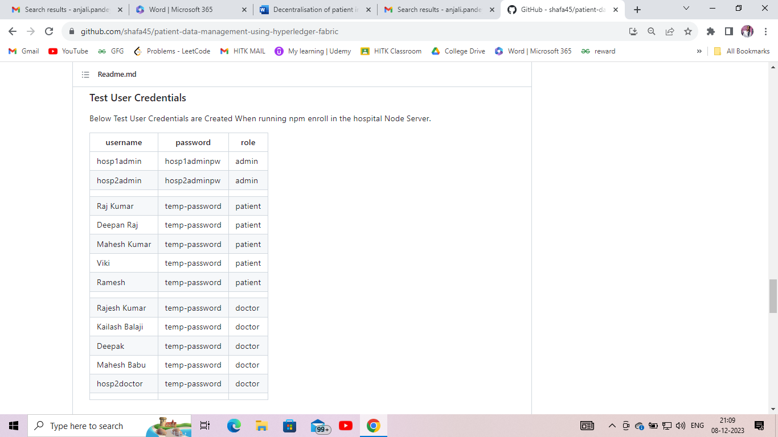

**5.2 Output**

**1. Home page and registration**

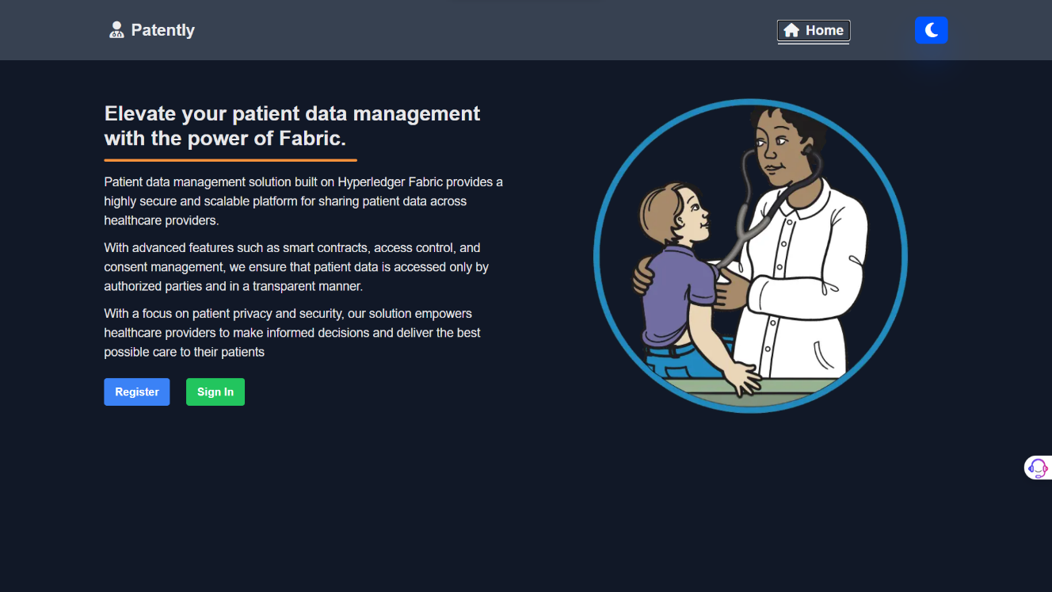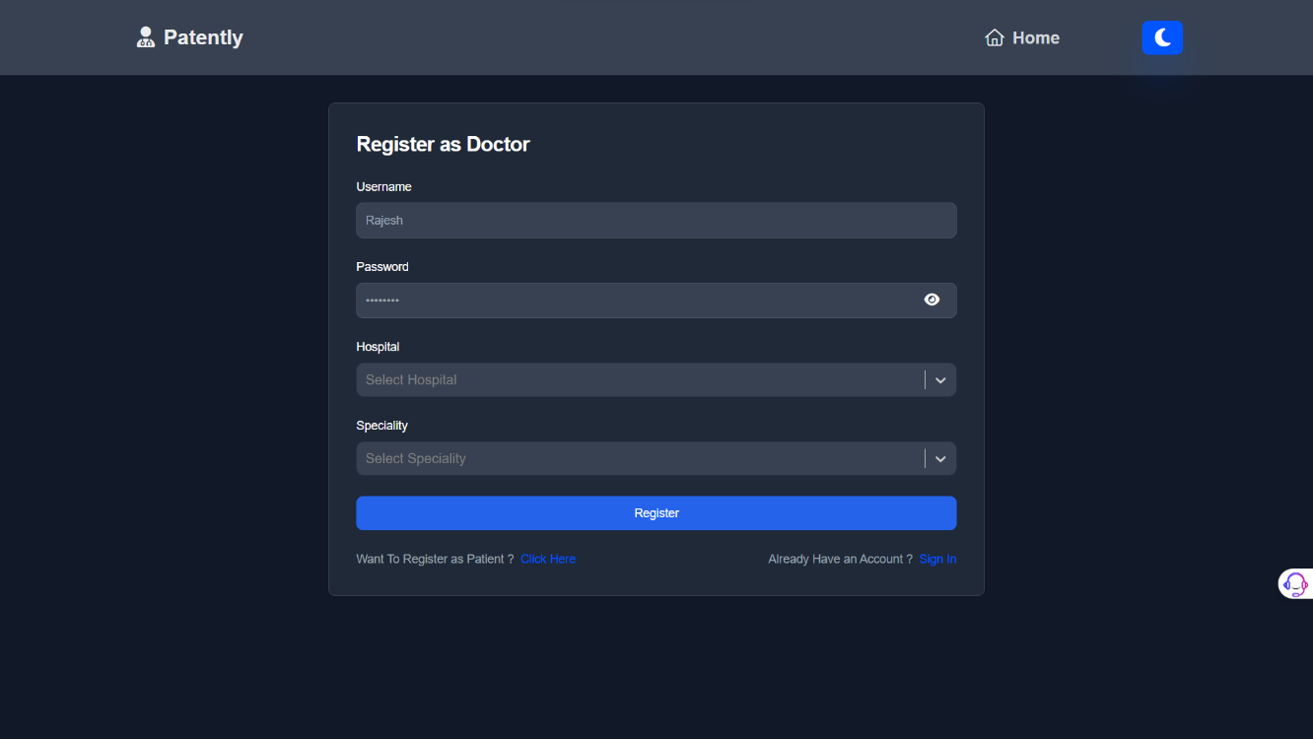

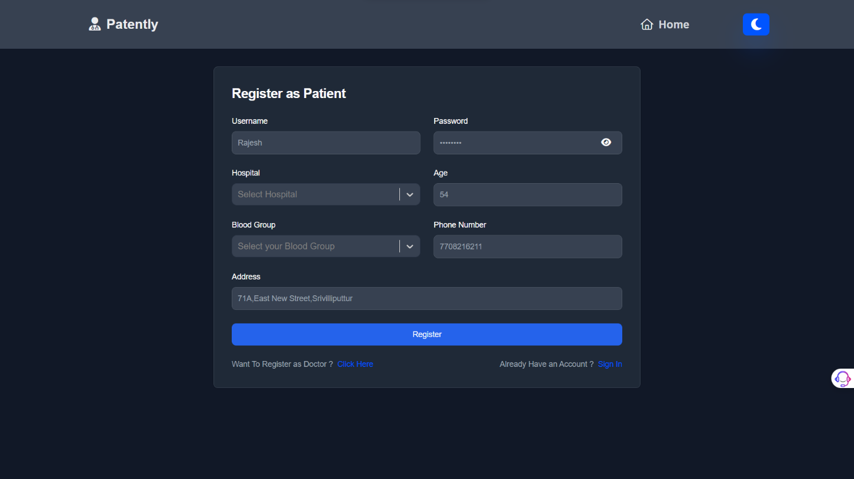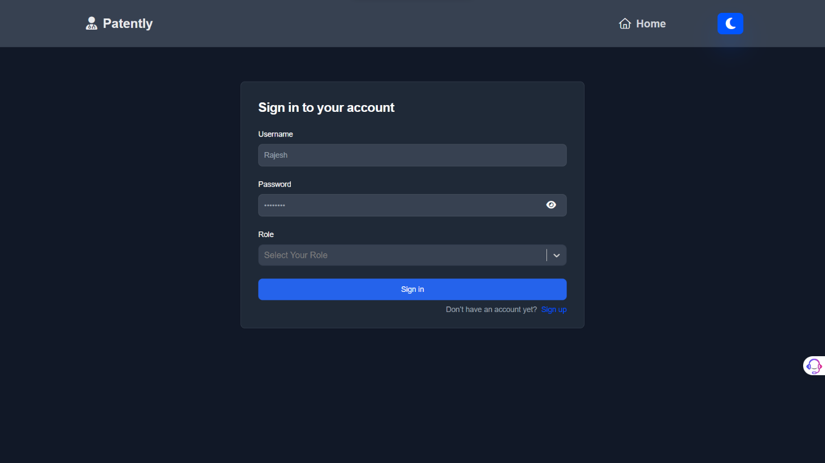

**2. Grant & Revoke access to doctor**

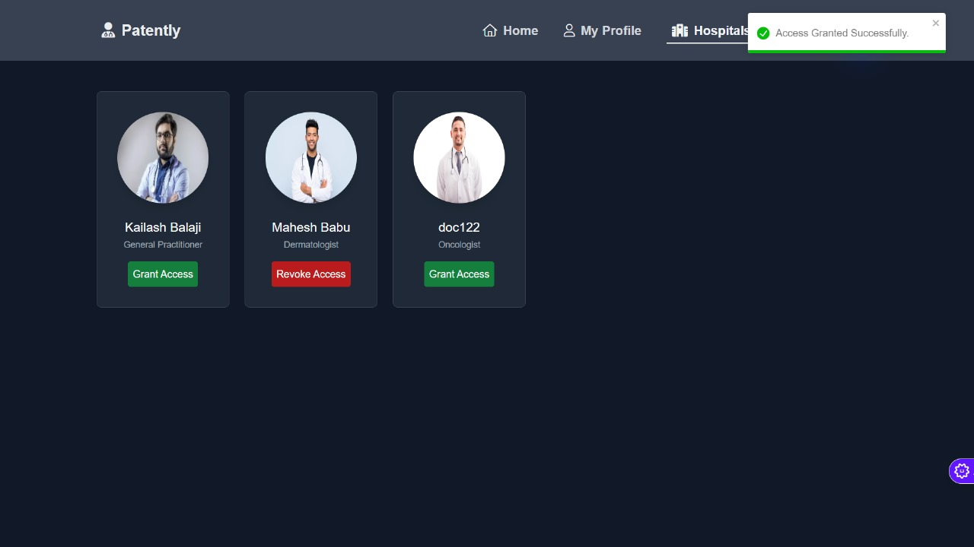

1. **Patient update its details**

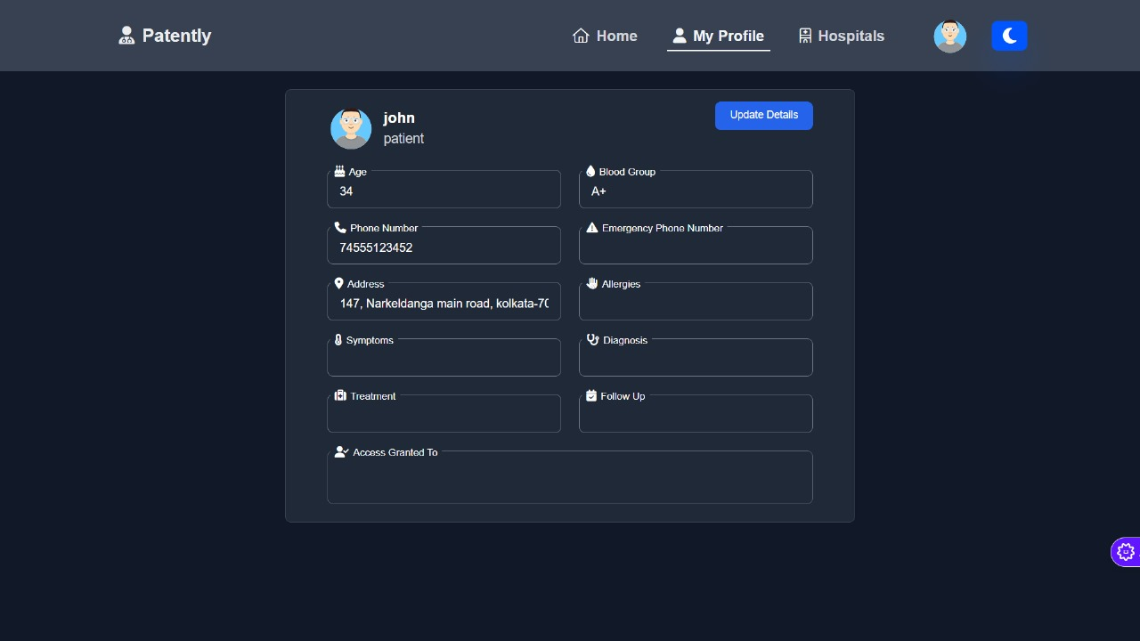

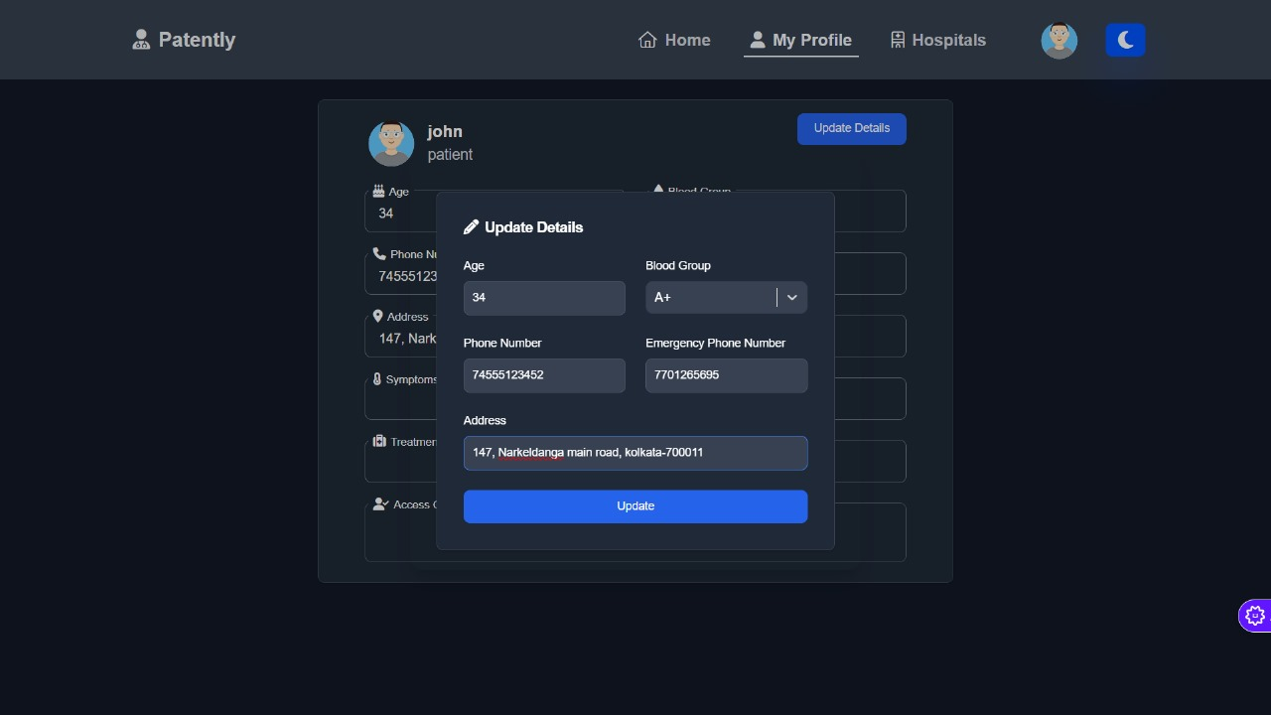

**4. Doctor dashboard**

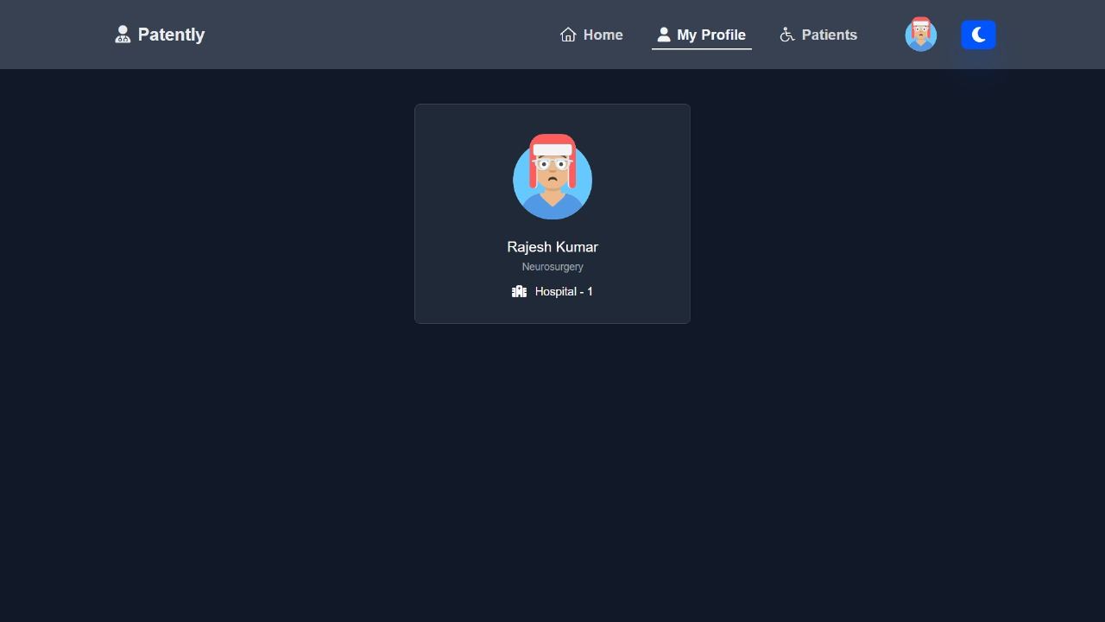

**5. Doctor view report**

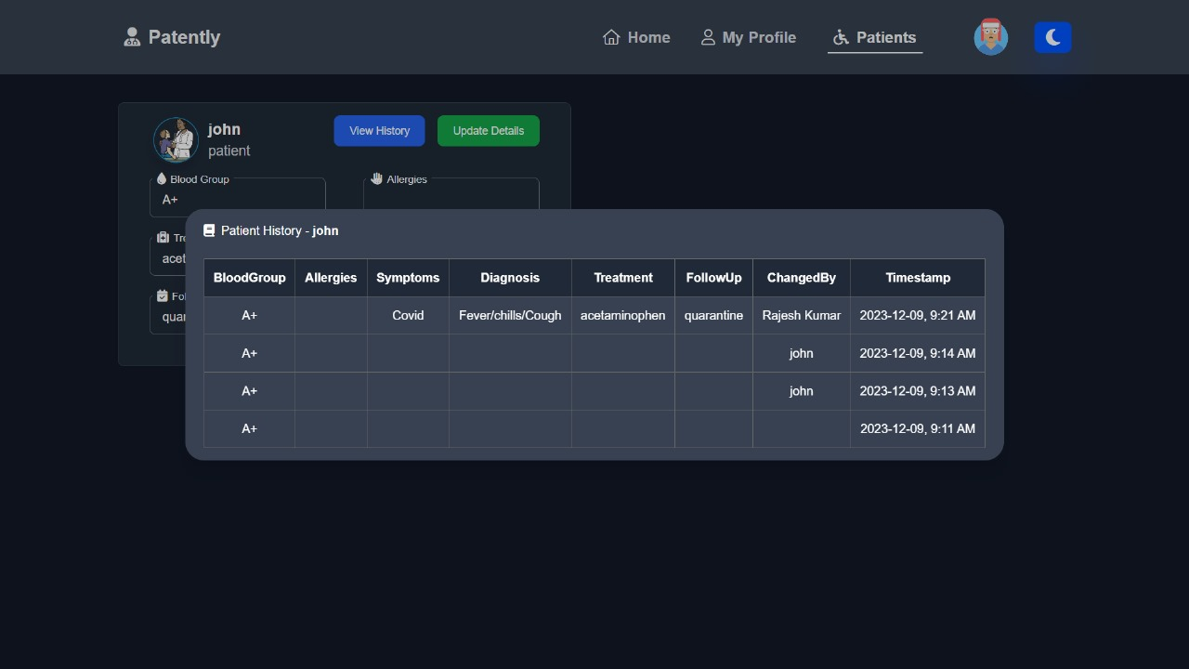

**6. Doctor update report**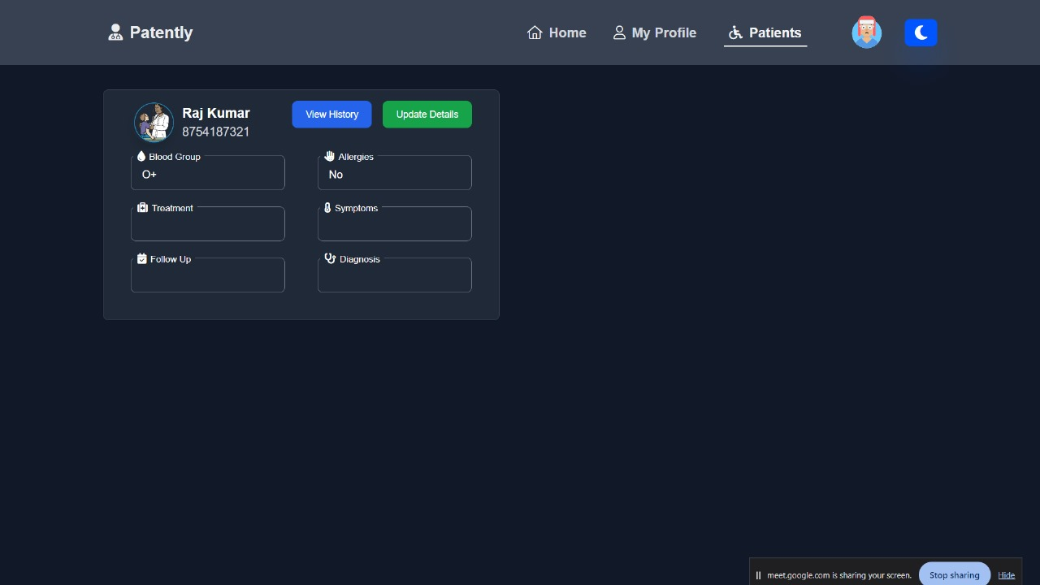

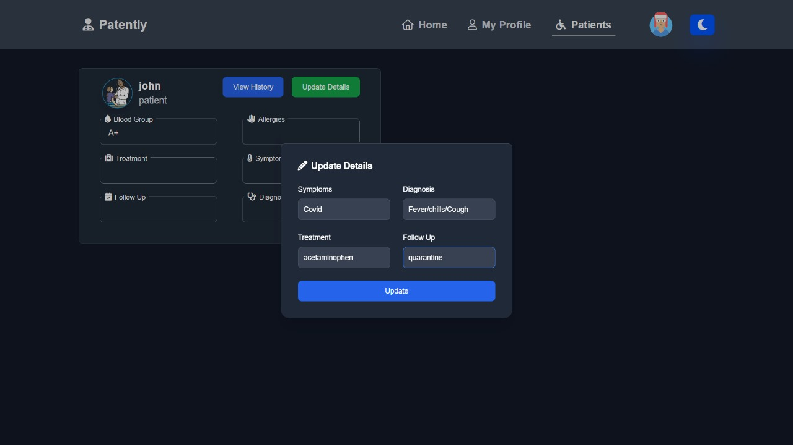

**6. CONCLUSION AND FUTURE WORK**

**6.1 Conclusion**

In conclusion, our research navigates the challenges confronting healthcare systems globally amid the digital age's advancements. Centralized systems, while advantageous, bear limitations hindering seamless data exchange, jeopardizing patient privacy, and impacting healthcare outcomes. Addressing these issues, our study centers on the "Decentralization of Patient Information," exploring its benefits, technological foundations, challenges, regulatory aspects, and future prospects for comprehensive insights.

Our investigation spans real-world use cases, ethical considerations, and potential impacts of decentralized patient care. Significantly, our research aims to revolutionize patient information management by offering enhanced data control, privacy, and stakeholder collaboration.

In essence, our research, spanning 300 words, outlines the challenges, explores the decentralized patient information paradigm, and underscores its potential to reshape healthcare. By offering insights and addressing critical aspects, this study contributes to a transformative discourse within the healthcare sector.

**6.2 Future Scope**

This project lays the groundwork for a decentralized patient information system. Future research will focus on integrating secure video conferencing and messaging, enabling **telehealth consultations**. This fosters a more **interactive and personalized patient experience**, improving accessibility and potentially leading to **enhanced diagnoses and treatment plans**. This expansion empowers patients and paves the way for a more **patient-centric future of decentralized healthcare**.

**7. REFERENCES**

[1] Gaganjeet Singh Reen, Allahabad. Manasi Mohandas and S. Venkatesan “Decentralized Patient-Centric E-Health Record Management System Using Blockchain and IPFS.”

[2] Gaurang Awatade, Gaurav Kasure, Suyog Padole, Yash Choudhary, Shital Sungare and Anil Kumar Gupta “A Survey: Blockchain-based Electronic Health Record System”

[3] Catherine Quantin, Gouenou Coatrieux, Vincent Breton, David-Olivier and Jaquet-Chiffelle, “Centralized versus Decentralized Management of Parents’ Medical Records”

[4] Syed Agha Hassnain Mohsan Ocean College, Shahbaz Ahmed Khan Ghayyur, Princess Nourah bint Abdulrahman, Hend Khalid Alkahtani, Imam, Nouf Al- Kahtani and Samih M. Mostafa “Decentralized Patient-Centric Report and Medical Image Management System Based on Blockchain Technology and the Inter-Planetary File System.”

[5] Sonam Sharma, “pubHeal – A Decentralized Platform on Health Surveillance of People”

[6] Akanksha Goel, S. Neduncheliyan,“An intelligent blockchain strategy for decentralized healthcare framework.”

[7] Zhijie Sun, Dezhi Han, Dun Li, Xiangsheng Wang, Chin-Chen Chang & Zhongdai Wu “A Blockchain-Based Secure Storage Scheme for Medical Information.”

[8] Tran Le Nguyen, “Blockchain in Healthcare: A New Technology Benefit for Both Patients and Doctors”

[9] Halima Mahmdi, Manel Ayadi, Amel Ksibi, Amal Al-Rasheed, Ben Othman Soufiene “SEMRAchain: A Secure Electronic Medical Record Based on Blockchain Technology”